NOAA Fisheries and CDFW Technical Staff Recommendation
for Klamath River Hatchery Operations in California Post-Dam Removal
April 26, 2018
Purpose:

Iron Gate Hatchery (IGH) was constructed in 1966 to mitigate for lost anadromous salmonid spawning and rearing habitat between Copco No. 2 Dam and Iron Gate Dam (IGD). The mitigation goals include a release of 6,000,000 Chinook salmon (5,100,000 fingerlings and 900,000 yearlings), 75,000 coho salmon yearlings, and 200,000 steelhead trout yearlings, annually. The Southern Oregon Northern California Coastal (SONCC) coho salmon Evolutionarily Significant Unit (ESU), which includes coho salmon produced at IGH, is listed as threatened under the California Endangered Species Act (CESA) and the federal Endangered Species Act (ESA). A Hatchery and Genetics Management Plan (HGMP) and Section 10(a)(1)(A) Enhancement of Survival Permit was issued to the CDFW in 2014 for the coho salmon program (Section 10(a)(1)(A) Permit 15755). Under the HGMP the purpose of the coho salmon program is to aid in the conservation and recovery of the Upper Klamath Population Unit of the SONCC coho salmon ESU by conserving genetic resources and reducing short-term extinction risks prior to future restoration of fish passage above IGD. Adult steelhead returns declined dramatically during the 1990’s for unknown reasons and no steelhead have been produced at IGH since 2012.

The amended Klamath Hydroelectric Settlement Agreement states that after removal of IGD and for a period of eight years, PacifiCorp shall fund hatchery operations and maintenance costs necessary to fulfill annual mitigation objectives developed by CDFW in consultation with NMFS. Iron Gate Reservoir currently provides the source of water for the operation of IGH and this source will be lost when IGD is removed. There is not an available source of water that can fully replace the volume required to maintain current production goals. Therefore, the purpose of this recommendation is to describe CDFW and NMFS’ proposal for continued hatchery operations given current knowledge of potential water supplies, facilities, and permit requirements.

Prioritization of Hatchery Production:

Given the CESA and ESA listed status of SONCC coho salmon, continuation of the coho salmon program under the principles of the HGMP is the highest priority for hatchery production following dam removal. Chinook salmon production is the second highest priority in order to provide continued opportunities for Tribal, sport, and commercial fisheries. Steelhead production, which has not occurred at IGH since 2012, is the lowest priority. Due to limited available water the recommendation is that steelhead production not occur after reservoir drawdown. The recommended production goals for coho salmon, Chinook salmon and steelhead are provided in Table 1.

Table 1. Current mitigation goals and the technical recommendation for production and release dates for coho salmon, Chinook salmon and steelhead at IGH and FCH facilities following dam removal.
Species / Life Stage | 1960’s Mitigation Goal  (at IGH) | Mitigation Goal Post-Dam Removal | Release dates
Coho Yearlings | 75,000 | 75,000 at FCH | March 15 – May 1
Chinook Yearlings | 900,000 | 115,000 at FCH | Oct 15 – Nov 20
Chinook Smolts | 5,100,000 | 3,400,000 at IGH | April 1 – May 31
Steelhead | 200,000 | 0

Facilities Recommendations:

Iron Gate Hatchery:
Retain operational components of IGH and invest in water use efficiency improvements such as water aeration and reuse. Utilize water diversion from Bogus Creek to operate the IGH hatchery (incubation) building, one 200’ adult holding pond, three 400’ raceways, and auxiliary fish trap. IGH will use 1.0 to 8.25 cfs October through May to rear 3.4 million Chinook smolts for release in April through May each year. Adult coho salmon and Chinook salmon will be trapped and held at IGH in the adult trap and holding pond. The Chinook salmon program will use a maximum of 4,000 adult fish to meet the production goals. The coho salmon program will use a maximum of 270 adult fish to meet the conservation goals identified in the HGMP and Section 10(a)(1)(A) Permit 15755.

Water Needs: The IGH hatchery building requires 1.5 cfs of water for egg incubation and fry rearing. The three raceways will need up to 2.25 cfs each (6.75 total), and the adult trap and holding pond will need 2 cfs (Table 2). Because anadromous salmonids currently use Bogus Creek, to reduce the potential threat of disease introductions to the hatchery, the water supply from Bogus Creek will need to be filtered and treated with Ultra Violet (UV) light.

To reduce the potential adverse effects of diverting water from Bogus Creek on naturally produced coho salmon, the pump station for the hatchery water supply should be constructed as far downstream as practicable. This will reduce the length of Bogus Creek rearing habitat affected by water withdrawals downstream of the pump station.

Water Aeration Needs: Water used for the raceways is currently plumbed to the fish trap and ladder. Since the water will be pumped from Bogus Creek (Table 3), aeration at the head of the raceway ponds will be needed to dissipate unwanted gasses from the water supply. Aeration will off-gas the water and allow re-oxygenation. Additional mid-raceway aeration may be needed to maintain dissolved oxygen levels near saturation.

Tagging and Marking: Coded Wire Tags (CWT) and marking will be conducted at IGH as fish reach the minimum size for tagging (200 fish/lb). It is anticipated that tagging will occur between March and May. Fish will need to be fed a high quality feed to optimize growth and improve health to meet a minimum size of 200 fish/lb to begin tagging and marking.

Adult Collection and Holding: Adult coho salmon and Chinook salmon will be trapped and held at IGH in the 200’ adult trap and holding pond. The existing trap will be utilized and a new adult holding pond will be needed to hold and separate adult salmon used for spawning. The Chinook salmon program will utilize a maximum of 4,000 adult fish to achieve target releases of 3,400,000 smolts and 115,000 yearlings. The coho salmon program will use a maximum of 270 adult fish to meet production of 75,000 yearlings as identified in the HGMP and Section 10(a)(1)(A) permit 15755.

Eggs: The Chinook and coho salmon eggs will be processed within the hatchery building at IGH, which has filtration and UV systems. Approximately 140,000 chinook eggs will be taken to Fall Creek Hatchery (FCH) for yearling incubation and rearing. All additional Chinook salmon smolts will be reared at IGH. Based on an annual evaluation of rearing conditions a decision will be made by CDFW and NOAA as to whether coho salmon eggs and fry will be hatched and reared at FCH, IGH, or a portion at each facility. Coho salmon at IGH will be hatched and reared within the hatchery building rearing tanks until approximately 300 fish per pound. Coho salmon will then be transported to FCH for rearing until release.

IGH Fish Releases: Release of Chinook salmon smolts will occur between April 1 and May 31 and after CWT tagging has occurred. Multiple thresholds have been identified that when reached would trigger release of fish from IGH. Those release thresholds include: water supply availability, water supply failure, poor water quality conditions or, threat of disease epizootics.

Bogus Creek flow to IGH: NMFS and CDFW will coordinate to minimize effects of Bogus Creek diversions on coho salmon and their critical habitat. Diversion rates from Bogus Creek will be monitored to ensure water diversions bypass at least 50% of the available flow at the point of diversion. However, Bogus Creek will be evaluated to assess habitat below the proposed hatchery diversion to determine the minimum amount of in-stream flow necessary to provide connectivity in Bogus Creek, and to ensure the habitat in Bogus Creek is maintained.

- Assessment of Bogus Creek habitat – NMFS and CDFW will examine the habitat in Bogus Creek below the proposed diversion at various low-flow levels to determine effects to habitat of various levels of water diversion.
- Monitoring of flow – Flow will be monitored through development of stage discharge relationships at key transects to determine if adequate fish passage conditions are provided. Data collection will begin in the spring and summer of 2018 and will continue as natural flow conditions in the stream vary.
- Coordination between agencies – Following the habitat assessment NMFS and CDFW will determine the appropriate flow level or percentage of diversion permitted each month given seasonal hatchery needs and fish development.
- Adjustments to Diversions - Based on the results of Bogus Creek evaluation, NMFS and CDFW may coordinate to change the percentage of flow permitted to be diverted from Bogus Creek to IGH to be protective of both Bogus Creek habitat and the hatchery program.
- Reporting – NMFS and CDFW will coordinate to determine reporting specifications for Bogus Creek diversions.

IGH Options:
- Water may be reused (recirculated) from the rearing raceways if chillers are installed to maintain suitable water temperatures.
- Filtration and UV: water from Bogus Creek used within the rearing facilities will need to be filtered and UV disinfected. Anadromous salmonids bring disease and pathogens to the supply water, and water used for rearing of fish in the raceways must be filtered and UV disinfected. The hatchery building currently has a filtration and UV system in place. The adult holding pond, trap, and ladder will not require treatment.

Fall Creek Hatchery:
Re-open the Fall Creek Hatchery (FCH) and upgrade facilities by modifying plumbing to accommodate installation of circular tanks and a UV system for raising coho salmon and Chinook salmon yearlings within the existing facility footprint (see Figure 1) while minimizing environmental impacts. The UV system will be required to treat and disinfect the egg incubation water source only. Additional space not depicted on Figure 1 will be needed for operations (e.g. settling basin, vehicle parking, pertinent buildings, tagging trailer, etc.); we believe the existing developed or disturbed sites would accommodate these needs with the exception of the settling basin. Non-consumptive water diversion from Fall Creek will support hatchery operations and will be returned back to the creek, minimizing adverse effects to Fall Creek aquatic resources. To address water supply, fish screening and pathology concerns fish cannot be allowed upstream of dam A or dam B.

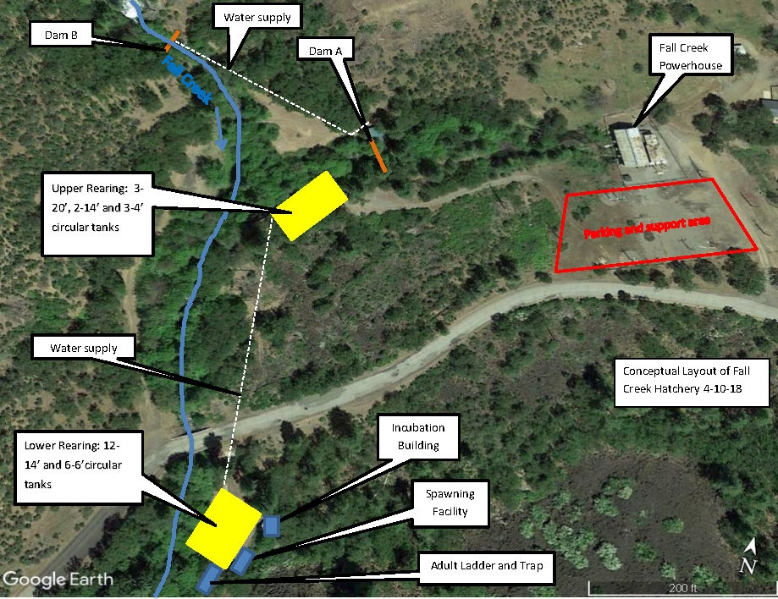

Figure 1. Conceptual layout of Fall Creek Hatchery.

Up to 10.09 cfs of water may be diverted from Pacific Power’s hydro-generation tail race canal, below the City of Yreka’s diversion facility provided this diversion does not result in adverse effect to the cold water habitats in Fall Creek and the Klamath River. Water will be gravity fed and plumbed to each rearing location and all circular tanks.

Adult Collection and Holding:
Option 1: Once adult Chinook and coho are returning to Fall Creek, an adult trapping and holding area is proposed; the adult holding area will be in one 14’ diameter circular tank in the lower rearing location. A fish ladder and trap will allow fish access to this tank.
Option 2: Adult trapping will be at the mouth of Fall Creek using a picket weir and trap. Once adults are trapped they will need to be transferred to the adult fish ladder and trap located at FCH.

Spawning: Spawning at FCH will be managed to meet the joint program goals at both IGH and FCH. Once adult Chinook and coho return to Fall Creek, the adults will be sorted for ripeness and spawned according to production goals for Chinook salmon and conservation goals described in the HGMP for coho salmon. If pass through water (3 to 4 cfs) from the lower tanks and incubation shed is insufficient to meet fish ladder and adult holding needs additional water (UV not required) may need to be diverted into the fish ladder.

Egg Incubation: FCH will incubate coho salmon and Chinook salmon eggs in the incubator shed using eight vertical flow incubator stacks. Each stack will use up to 10 gpm, for a total of 80 gpm. The incubators will need to be treated with a 100 gpm in-line UV treatment system. The water supply for the incubator shed will require UV treatment regardless of the need to UV treat other water sources at FCH.

Circular Tanks: Rearing at FCH will consist of two areas: the upper ponds and lower ponds. For each location, circular tanks will sit within the existing concrete rearing pond footprints. The upper ponds will consist of 3 - 20’circular tanks, 2 - 14’ circular tanks, and 3 - 4’ circular tanks. The lower ponds will consist of 12 – 14’ circular tanks, and 6 – 6’ circular tanks. The incubation building, fish ladder, and adult capture and holding ponds will be located adjacent to the lower raceways (Figure 1).

Water needs: Water will be diverted from Dam A to provide 2.2 cfs to the upper rearing area, and 5.65 cfs to the lower rearing area. Up to 2.2 cfs would be diverted for the fish ladder and adult capture area during the months of October through January. The total volume of water required to operate the FCH is 10.09 cfs (Table 4) which includes additional water from unused tanks to operate the fish ladder and trapping area.

CWT and Marking: CWT marking and adipose fin clipping of the Chinook salmon yearlings reared at FCH are proposed to be processed by hand using Mk IV CWT tagging machines. It is anticipated that hand processing these Chinook yearlings with two CWT machines can be completed in 7 to 15 days. Coho salmon will be marked with a left maxillary fin clip by hand and the hand clipping can be completed in roughly 10 to 20 days.

FCH Fish Releases: Release strategy for the Fall Creek Hatchery has not been determined as of this date. Planned dates of release are October 15 through November 20 for Chinook salmon yearlings, and March 15 through May 1 for coho salmon yearlings. Options include direct release at FCH or IGH.

FCH Options:
- CDFW Pathology will investigate fish found above hatchery intakes (Dam A and Dam B) for pathogens and virology.

Assumptions:

- Hatchery production at IGH and FCH under this technical memorandum is proposed to be limited to the eight years following dam removal. After eight years the hatcheries will cease operations.
- IGH and FCH must be operational prior to draw down per the Klamath Hydroelectric Settlement Agreement (KHSA 2016, see section 7.6.6.B).
- CDFW will employ Best Management Practices in order to minimize discharge at Iron Gate and Fall Creek hatcheries.
- Water quality treatment is proposed to occur in a settling basin, and discharging into Fall Creek, in compliance with the North Coast Regional Water Quality Control Board requirements.

Table 2. Estimated water needs by month at IGH to support rearing 3.4 million chinook smolts (cfs).
 | January | February | March | April | May | June | July | August | September | October | November | December
Rearing Ponds | 2.25 | 2.25 | 2.25 | 6.75 | 6.75 | 0.00 | 0.00 | 0.00 | 0.00 | 0.00 | 0.00 | 2.00
Hatchery Building | 1.50 | 1.50 | 1.50 | 1.50 | 1.50 | 0.00 | 0.00 | 0.00 | 0.00 | 1.50 | 1.50 | 1.50
Spawning | 0.00 | 0.00 | 0.00 | 0.00 | 0.00 | 0.00 | 0.00 | 0.00 | 0.00 | 1.00 | 1.00 | 1.00
Adult Holding & Ladder | 0.00 | 0.00 | 0.00 | 0.00 | 0.00 | 0.00 | 0.00 | 0.00 | 0.00 | 2.00 | 2.00 | 2.00
Total (cfs) | 3.75 | 3.75 | 3.75 | 8.25 | 8.25 | 0.00 | 0.00 | 0.00 | 0.00 | 4.50 | 4.50 | 6.50

Table 3. Observed minimum, maximum, and 4-year average flow in cfs by month in Bogus Creek from 2013 to 2017.
(cfs) | January | February | March | April | May | June | July | August | September | October | November | December
Min. Flow | 15.75 | 26.25 | 25.75 | 21.25 | 12.00 | 6.50 | 3.75 | 4.50 | 4.00 | 12.60 | 20.60 | 18.30
Max Flow | 132.50 | 127.25 | 64.00 | 33.75 | 29.00 | 18.00 | 7.50 | 7.25 | 17.33 | 32.30 | 22.00 | 53.30
4 year avg. flow | 34.23 | 41.68 | 39.48 | 28.4 | 18.92 | 10.02 | 6.11 | 5.96 | 8.97 | 16.56 | 19.62 | 28.85

Table 4. Estimated Water Needs at FCH rearing 115,000 chinook yearlings and 75,000 coho (cfs).
 | January | February | March | April | May | June | July | August | September | October | November | December
Round Tanks | 1.26 | 1.29 | 1.58 | 1.66 | 1.08 | 0.58 | 1.01 | 1.48 | 2.29 | 3.30 | 4.06 | 1.14
Hatchery Building | 0.18 | 0.18 | 0.18 | 0.18 | 0 | 0 | 0 | 0 | 0 | 0.18 | 0.18 | 0.18
Spawning | 0 | 0 | 0 | 0 | 0 | 0 | 0 | 0 | 0 | 0.67 | 0.67 | 0.67
Adult Holding & Ladder | 4.33 | 0 | 0 | 0 | 0 | 0 | 0 | 0 | 0 | 4.33 | 4.33 | 4.33
Total (cfs) | 5.77 | 1.47 | 1.76 | 1.84 | 1.08 | 0.58 | 1.01 | 1.48 | 2.29 | 8.48 | 9.24 | 6.32

